
VIDES UK

Registered Charity No: 1166876

Vides Office, 61A Mansion Drive, Croxteth, Liverpool, L11 9DP

e-mail: videsoffice@videsuk.org.uk

Tel: 0151 548 5309

Are you or will you be 17 by 19th June 2020?

Have you thought about what you are going to do this year to make a difference in your life and in the world?

Are you interested in voluntary work either here in the UK or abroad?

Would you like to make a difference in the lives of children in greatest need?

A

‘VIDES VIEW Day’
may hold the answer!

When? Saturday 14th March

Time? 10am – 4pm

Where? Glasgow

Cost? A contribution of £5

VIDES View Day

Application Form

Name: ……………………………………………………………………………………………………………… Male / Female*
Date of Birth: ……………………………………… Age: .......
Address:……………………………………………………………………………..............................................................................................................………………………………………………………………………………………………………………………………………………..............................................................................................................................
Telephone No: ………………………………………………………………………
Email: ……………………………………………………………………………………………………………………………………………………….

I enclose £5 full payment to secure my place. Cheques should be made payable to VIDES UK.

If you have any specific dietary needs or requirements please give details below:

……………………………………………………………………………………………………………………………………………………………………………………………………………………………………………………………………………………………………………………
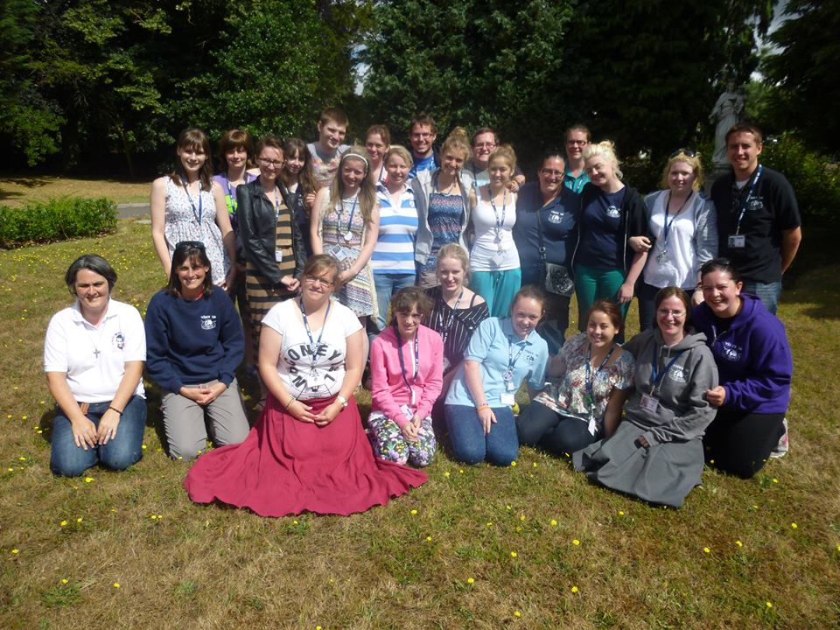
Image use permission form
VIDES UK captures images to use in its mission of creating public awareness of the numerous projects and schemes managed, organised, initiated, partnered or promoted by the Salesian Sisters in the UK. Images may also be used in related publications and for purposes such as education and training.
These images can be as stills or moving images: photographs, videos, streaming or audio recordings.
The images are not sold commercially and are only stored and used to support the work undertaken in line with the provisions of the Data Protection Act.
By consenting to have your image captured, or the image of a young person for whom you are responsible, we ask that you agree to VIDES UK using it.
The uses may be, without limitation, as reproduction or adaptation in printed media, online or broadcast throughout the world but will not generate any right to payment in perpetuity regardless of how or where the material is used. This is not meant to be negative in any way but simply to ensure you are aware that image use will not generate payment and that by allowing image capture, you give consent to use of images by VIDES UK.
I GIVE PERMISSION FOR THE USE OF IMAGES AS INDICATED

SIGNED DATE

FULL NAME

ADDRESS

IMAGE REF (OCCASION) VIDES VIEW Day 2020 - Glasgow DATE

Please note
The press are exempt from the Data Protection Act and may want to include the names and personal details in the media.
1) We will not use the personal details or full names (which means first name and surname) of any child or adult in a photographic image or video, on our websites or in any of our other printed publications without good reason. For example, we may include the full name of a pupil in a newsletter to parents if the pupil has won an award.
2) If we name a young person in text we will not use a photograph of that person to accompany the article without good reason (see point 1 above).
3) We will not include personal e-mail or postal addresses, or telephone or fax numbers on video, on our websites or in other printed publications.

Confidential Medical Consent Form *Delete as applicable

[1] I (name) …………………………. have / have not* any medical condition and/or medication which should be administered e.g. asthma, diabetes or epilepsy.
Please give details below
…………………………………………………………………………………………………………………………………………………………………………………………………………………………………………………………………………
(Please note that medication must be handed to the group leader, in a clear labelled bag, with clear instructions and a parent’s signature, if the young person is under 18).

[2] I (name) ……………………………have / have not* any known allergies or sensitivities e.g. penicillin. If so please give details:

………………………………………………………………………………...............................................

[3] I have / have not* a disability you may need to be aware of. If so please give details:

………………………………………………………………………………..............................................

[4] I have / have not been immunised against TETANUS within the last 3 years. Should I come into contact with any infectious diseases within 3 weeks of the event I will inform you.

[5] In the event of illness or an accident requiring emergency hospital treatment, I authorise a recognised adult leader to sign on my behalf/son or daughter’s behalf, any written form of consent required by the hospital authorities.

[6] Please give details of your doctor:

Name: ………………………………………………………………
Telephone: ……………………………...........................
Address:……………………………………………………………………………………………………………………………………………………………………………………………………………………………………………………………

[7] In case of emergency please give details of a relative or friend whom we should contact:
Name: ………………………………………………………………….
Telephone: ……………………………..............................
Address:………………………………………………………………………………………………………………………………………………………………………………………………………………………………………………............

Signature: ...................................................... Date: .............................

The above information is correct and I give my consent for my son/daughter to attend the ‘VIDES View’ Day on 25th January 2020
Signature of Parent /Guardian if under 18 yrs …………………………………...................................................

Contact Number: ……………………………………………………………………………………………………………

Please send your application form to VIDES UK @

Vides Office
61a Mansion Drive
Croxteth

Liverpool

L11 9DP
Tel: 0151 548 5309

Or hand it to Sr. Anne Frances directly

